Name: Catherine Smereena Dommaty.
Group:07

ALY 6040 –Data Mining Applications.
Module 3 Project.
Title: Exploratory Data Analysis and Clustering Analysis of Netflix Dataset.

Introduction:

The Netflix dataset is a comprehensive informational resource that covers a wide range of films and television series that are accessible on the site. With millions of users throughout the globe, Netflix has established itself as a major player in the entertainment sector by providing a huge selection of content to suit a wide range of interests and preferences. In order to obtain an understanding of the fundamental properties of the dataset, we have focused on performing a thorough exploratory data analysis (EDA) in this study. We will also investigate clustering analysis to find possible groupings and patterns in the data.

My particular responsibility in a team effort is to perform cluster analysis, a potent method for classifying data into discrete groups according to similarities in observations. Our goal is to uncover underlying structures and trends in the Netflix dataset by finding clusters, which may not be readily visible using typical EDA methods alone. Finding trends through clustering analysis, such as recurring topics, genres, or viewer preferences, is helpful for targeted marketing campaigns, content recommendation systems, and content creation choices.

Data Loading and Pre-processing:
To make sure the data is clean and ready for analysis, we import the Netflix dataset into R in this stage and carry out any necessary pre-processing. This comprises:

Loading the Dataset: A CSV file is read into a data frame using the read.csv function, which is used to read the dataset into R.
Using the as factor function, categorical variables such as "type" and "rating" are transformed into factor variables. By doing this, you may be confident that R views these variables as categorical instead than numerical.
Managing Value Missing: Logical indexing is used to replace missing values in variables such as "director" and "cast" with "Unknown" to maintain consistency and completeness in the data.
Transformation Date Formats: The date a film or television program was added is indicated by the "date_added" field.

Standardisation: In this stage, the numerical variables "duration" and "release year" are set to have a standard deviation of one and a mean of zero. By ensuring that all variables are on the same scale through standardisation, bigger magnitude variables are kept from controlling the clustering process.

Clustering Analysis:
Elbow Method: A graphical method for determining the ideal number of clusters in a dataset is the Elbow method. It entails graphing the within-cluster sum of squares (WSS) versus the number of clusters and fitting k-means clustering models for various values of k. The ideal number of clusters is thought to be represented by the "elbow" point in the plot, where the rate of WSS drop slows down.

# Elbow method
fviz_nbclust(scaled_data, kmeans, method = "wss") +
labs(subtitle = "Elbow method")

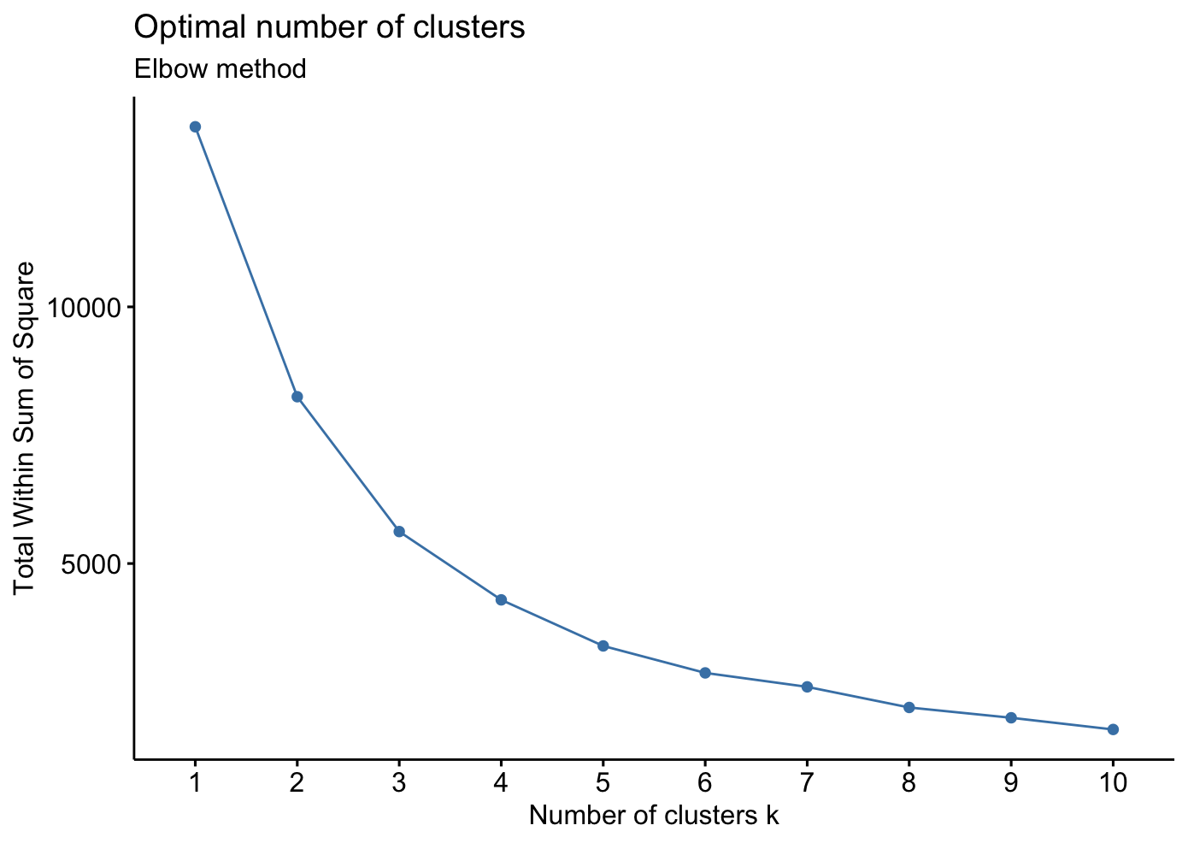

The number of clusters (k) being analysed within the given range is displayed on the x-axis. The k-means clustering model is fitted to a given value of k, which is represented by each tick mark on the x-axis.
The within-cluster sum of squares (WSS), which shows the sum of squared distances between each data point and its designated cluster centroid, is represented on the y-axis. Better cluster separation and tighter clustering are indicated by a lower WSS value.
Elbow Point: The Elbow method's primary goal is to locate the plot's "elbow" point, or the inflection point at which the rate of WSS decline sharply slows down. The number of clusters at this time is ideal; adding more clusters after this may not result in significant improvements in clustering quality.

By visually examining the plot and locating the point where the rate of decline in WSS abruptly slows down to produce "elbow-like" shape, one can calculate the optimal number of clusters in the context of the Elbow technique. This point represents the ideal ratio of clustering performance to model complexity (number of clusters). It's crucial to remember that the elbow point interpretation might occasionally be arbitrary and may call for more research or confirmation.

Silhouette Method: One common method for evaluating the quality of clustering in a dataset is the silhouette method. For every observation, it computes the silhouette coefficient, a metric that expresses how similar an observation is to its own cluster in relation to other clusters. A high silhouette coefficient value implies that the observation is well-clustered, whereas a low value suggests that it might be misclassified. The silhouette coefficient has a range of -1 to +1.
# Silhouette method
fviz_nbclust(scaled_data, kmeans, method = "silhouette") +
labs(subtitle = "Silhouette method")

The number of clusters (k) is represented on the x-axis of the graph created by the Silhouette technique visualisation, and the average silhouette width is represented on the y-axis. The following is an explanation of the graph's elements:

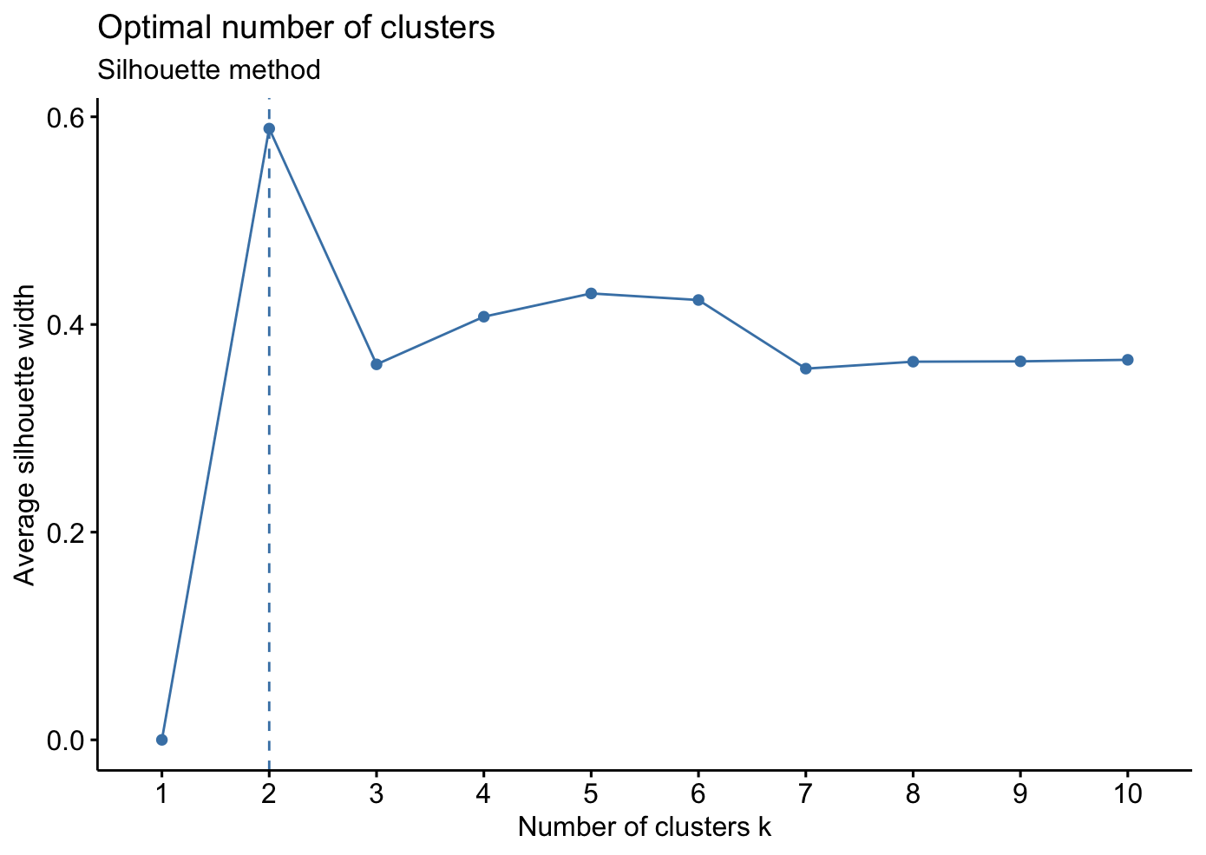

The x-axis displays the number of clusters (k) under evaluation within the given range. The silhouette coefficient is computed for each tick mark on the x-axis, which corresponds to a particular value of k.
The average silhouette width for each value of k across all observations is represented by the y-axis. Greater average silhouette width corresponds to higher quality clustering; values nearer +1 denote more distinct clusters.
By optimising the average silhouette width, the Silhouette technique determines the ideal number of clusters. Finding the value of k that produces the greatest average silhouette width is the goal of analysts since it shows that the data points are well-clustered, have strong cohesiveness within clusters, and have low coupling between clusters. With the silhouette method, a quantitative.

Gap Statistic: Another technique for figuring out how many clusters in a dataset is ideal is to use the gap statistic. The within-cluster sum of squares (WSS) of the observed data is compared to reference datasets that were produced at random. The Gap statistic assists in determining the statistical significance of the observed clustering structure by creating reference datasets that have similar features with the original data.
# Gap statistic
fviz_nbclust(scaled_data, kmeans, method = "gap_stat") +
labs(subtitle = "Gap statistic method")
# Standardize the data
scaled_data <- scale(netflix[, c("release_year", "duration")])

The number of clusters (k) is represented on the x-axis of the graph created by the gap statistic method, and the gap statistic is represented on the y-axis. The following is an explanation of the graph's elements:

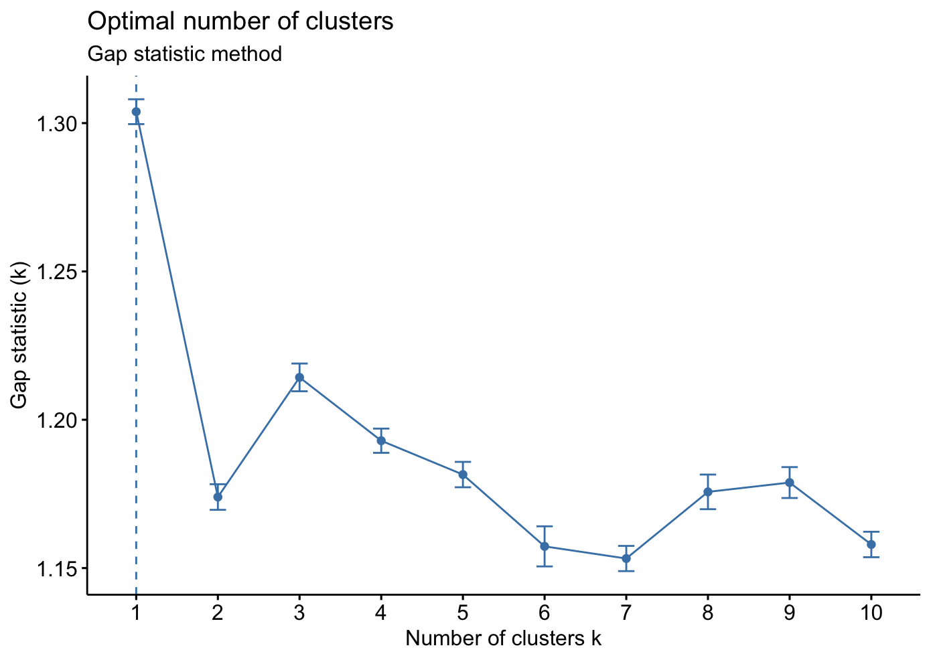

The number of clusters (k) being analysed within the given range is displayed on the x-axis. The gap statistic is computed for each value of k that each tick mark on the x-axis corresponds to.
The gap statistic, which shows the difference between the observed and expected WSS for each value of k, is plotted on the y-axis. Greater evidence for the existence of separate clusters in the data is indicated by a bigger gap statistic.

D Index: The D Index is a graphical method used to determine the optimal number of clusters in a dataset. It evaluates the clustering structure by considering the second differences in the D Index plot. The D Index measures the discrepancy between the observed within-cluster dispersion and the expected within-cluster dispersion under a random uniform distribution. By examining the plot of the D Index, analysts aim to identify significant peaks or knees that correspond to a substantial increase in the value of the D Index, indicating the presence of distinct clusters in the data.
# D index
set.seed(123) # for reproducibility
res.dindex <- NbClust(scaled_data, distance = "euclidean", min.nc = 2, max.nc = 5, method = "Dindex")
fviz_nbclust(res.dindex)

# Visualize the D index
fviz_nbclust(res.dindex)

# Extract the coordinates of the final centers
round(res.dindex$All.index, digits = 2)

# Extract the coordinates of the final centers
round(res.hubert$centers, digits = 2)

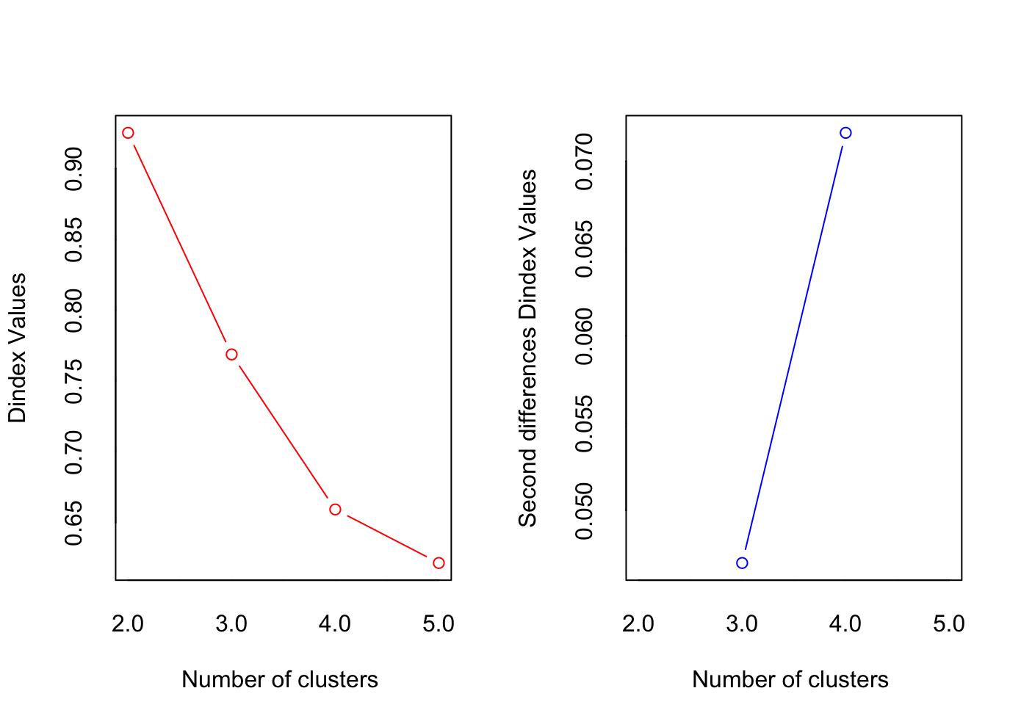
X-axis (Number of Clusters k): This graph displays the number of clusters (k) that are being assessed within the given range. With each tick mark on the x-axis, a particular value of k for which the D Index is computed is associated.
Y-axis (D Index Value): This shows the difference between the actual and predicted within-cluster dispersion. It is a measure of discrepancy. There is more proof that there are different clusters in the data when the D Index value is larger.

By locating notable peaks or knees in the D Index plot, the ideal number of clusters can be found using the D Index approach. Adding more clusters beyond these points might not significantly increase the quality of the clustering, as they reflect the ideal balance between model complexity and clustering performance. Analysts can determine the ideal number of clusters that most accurately represent the underlying structure of the data by choosing the value of k that corresponds with the prominent peaks in the D Index plot.
The Hubert and D indices both indicate that two clusters may be optimal, as evidenced by significant changes in the indices at this point.

Analysis of Hierarchical Clustering:
With the use of pairwise distances, hierarchical clustering is a potent technique that iteratively merges or splits clusters to show hierarchical relationships among data points. This method offers insights into the data's underlying structure without requiring a predetermined number of clusters.

Single Linkage: The smallest pairwise distance between points from various clusters is used to create clusters in single linkage hierarchical clustering. This approach typically results in elongated clusters, some of which may have distant points inside them. Long, stretched branches are frequently seen in the resulting dendrogram, which represents the propensity of one connection to merge points according to their closest neighbours. Even though a single connection can capture extended cluster structures, noise and outliers in the data may still affect it.
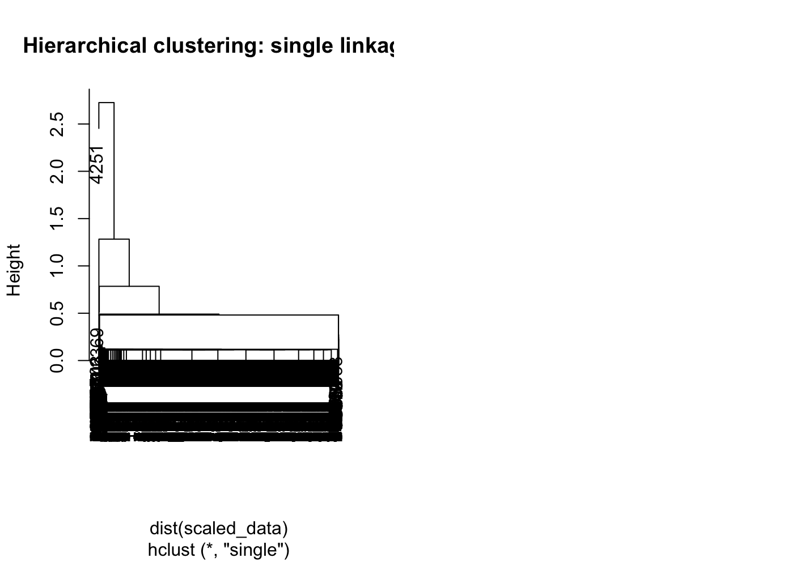

Complete Linkage: Clusters are created using the largest pairwise distance between points from several clusters in complete linkage hierarchical clustering. When compared to single connection, this technique typically yields more compact and spherical clusters. When complete linkage occurs, points tend to merge based on their distant neighbours, resulting in a dendrogram that is usually shorter and more balanced. Complete linkage can be used to identify well-separated clusters since it is less susceptible to noise and outliers.

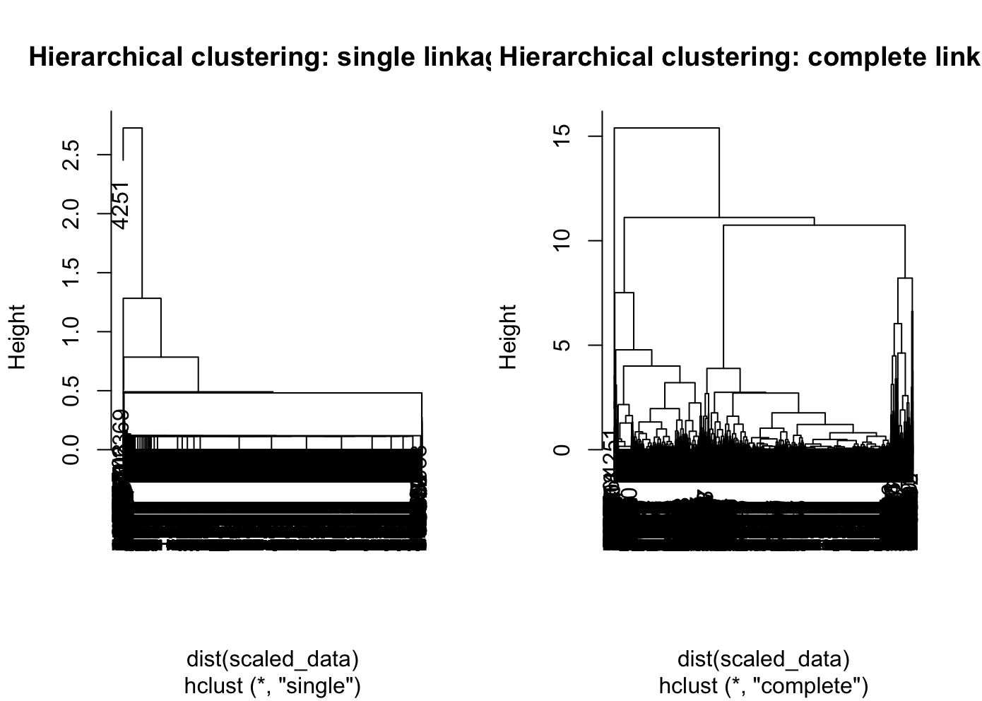

Average Linkage: Linkage average The average pairwise distance between points from various clusters is computed using hierarchical clustering. This approach considers the general similarity across clusters to achieve a balance between single and complete linkage. Given the moderate merging criterion of average linkage, the resulting dendrogram might show intermediate branch lengths. Average linkage can successfully capture both compact and extended cluster structures and is resistant to noise and outliers.
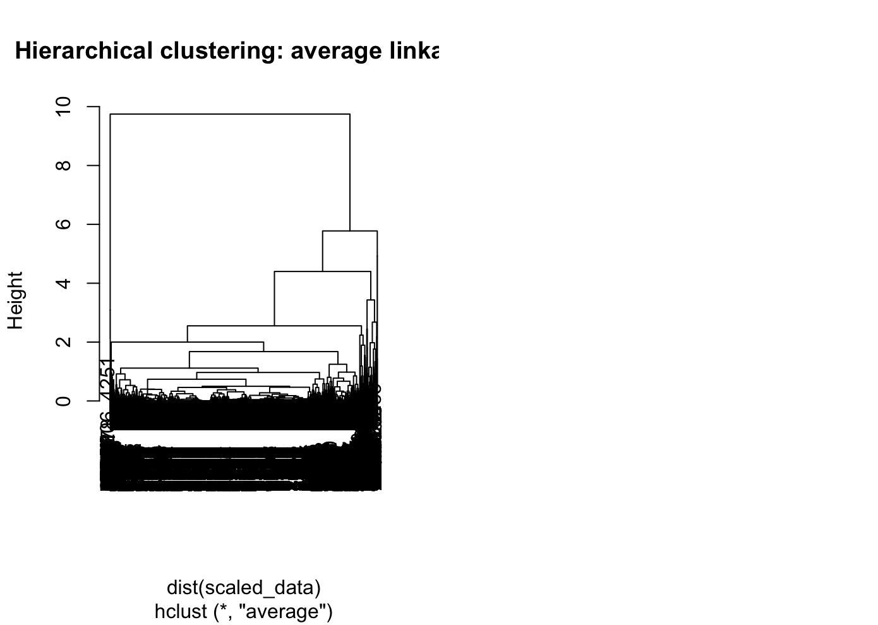

1.The dendrogram generated by single linkage hierarchical clustering displays elongated branches, indicating the merging of points based on their nearest neighbours.
2.In contrast, the dendrogram produced by complete linkage hierarchical clustering shows more compact branches, suggesting the merging of points based on their farthest neighbours.
3.The dendrogram from average linkage hierarchical clustering exhibits intermediate branch lengths, reflecting a balance between merging based on nearest and farthest neighbours.

Based on the analysis:
1.Two clusters may naturally arise from the data, which could indicate distinct genres or audience preferences.
2.These clusters could be used by the data owner to customise marketing campaigns or suggestions for various target segments.
3.Additional variables like viewer ratings or outside sourced genre classifications could be incorporated to improve the accuracy and insights of clustering.

Conclusion:
In Conclusion, the Netflix dataset's exploratory data analysis (EDA) and clustering analysis have shed important light on the properties and organisation of the data. We learned about the distribution of content categories, ratings, release years, and runtime durations through the EDA process. The examination of these variables was made easier by visualisations like bar graphs and histograms, which showed patterns and trends in the dataset.

Our understanding was further enhanced by the clustering analysis, which showed possible links and groupings among the findings. We were able to determine the best cluster configurations and use dendrograms to depict the cluster structures thanks to methods like k-means clustering and hierarchical clustering. The Hubert Index, D Index, Gap statistic, Elbow method, Silhouette method, and Hubert Index offered mathematical tools for figuring out how many clusters were right.

Overall, the analysis uncovered valuable insights that can inform decision-making for the data owner, such as content categorization, user segmentation, and recommendation system improvement. By understanding the underlying structure of the Netflix dataset, stakeholders can make informed decisions to enhance user experience, optimise content recommendations, and drive business growth. Further analysis and experimentation with different clustering algorithms and parameters could yield additional insights and opportunities for refinement.

References:
1.Nayana, C. K. (2022). Netflix Movies and TV Shows. Kaggle. Link:https://www.kaggle.com/datasets/nayanack/netflix?resource=download
2.Kaufman, L., & Rousseeuw, P. J. (2009). Finding groups in data: An introduction to cluster analysis (Vol. 344). John Wiley & Sons.
Link:https://www.wiley.com/en-us/Finding+Groups+in+Data%3A+An+Introduction+to+Cluster+Analysis-p-9780471735786
3.Tibshirani, R., Walther, G., & Hastie, T. (2001). Estimating the number of clusters in a data set via the gap statistic. Journal of the Royal Statistical Society: Series B (Statistical Methodology), 63(2), 411-423.
Link:https://rss.onlinelibrary.wiley.com/doi/abs/10.1111/1467-9868.00293
4.Milligan, G. W., & Cooper, M. C. (1985). An examination of procedures for determining the number of clusters in a data set. Psychometrika, 50(2), 159-179.
Link:https://link.springer.com/article/10.1007/BF02294245
5.Ward Jr, J. H. (1963). Hierarchical grouping to optimise an objective function. Journal of the American statistical association, 58(301), 236-244.
6.Rousseeuw, P. J. (1987). Silhouettes: a graphical aid to the interpretation and validation of cluster analysis. Journal of computational and applied mathematics, 20, 53-65
Link:https://www.sciencedirect.com/science/article/pii/0377042787901257
7.Tibshirani, R., Walther, G., & Hastie, T. (2001). Estimating the number of clusters in a data set via the gap statistic. Journal of the Royal Statistical Society: Series B (Statistical Methodology), 63(2), 411-423..Link:https://rss.onlinelibrary.wiley.com/doi/abs/10.1111/1467-9868.00293

